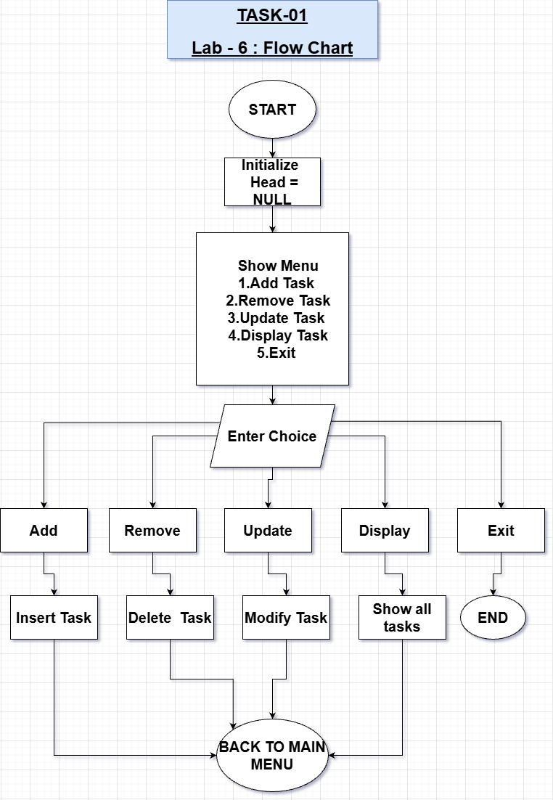
FLOWCHART
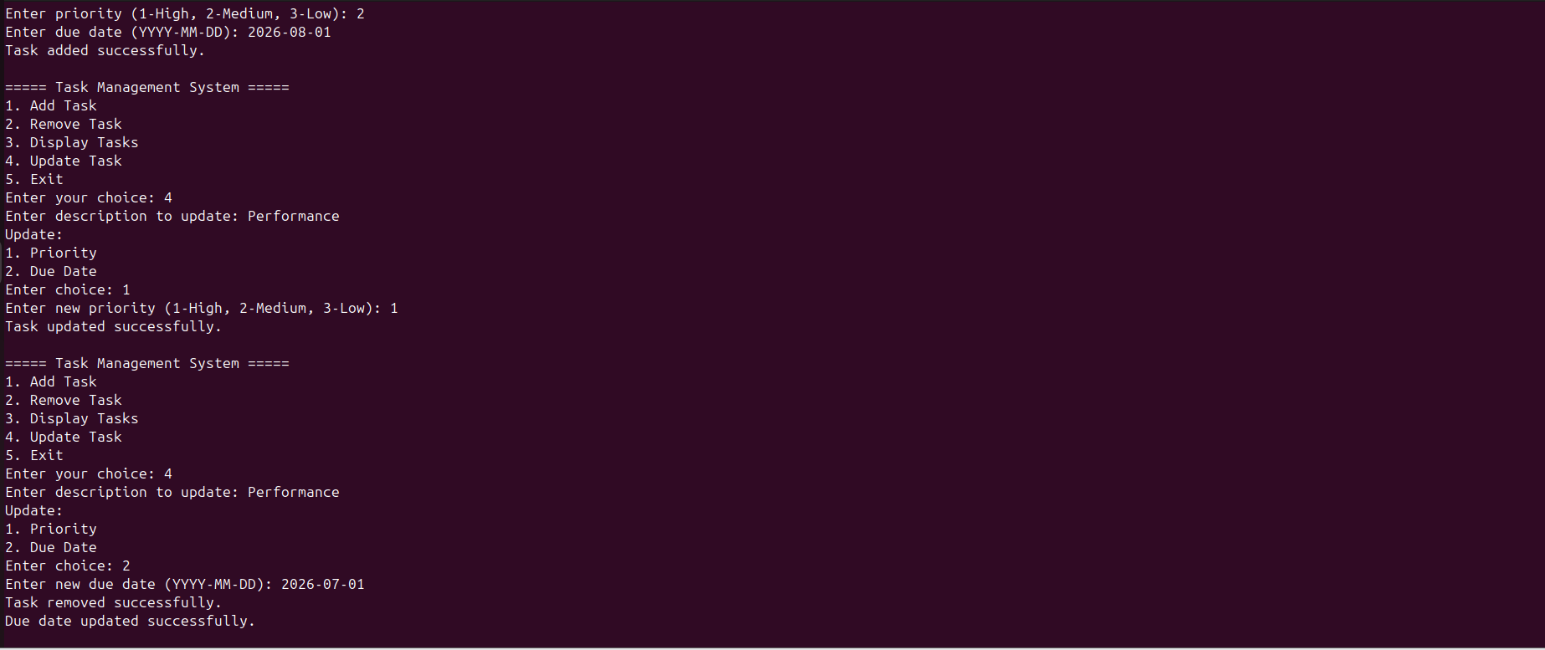
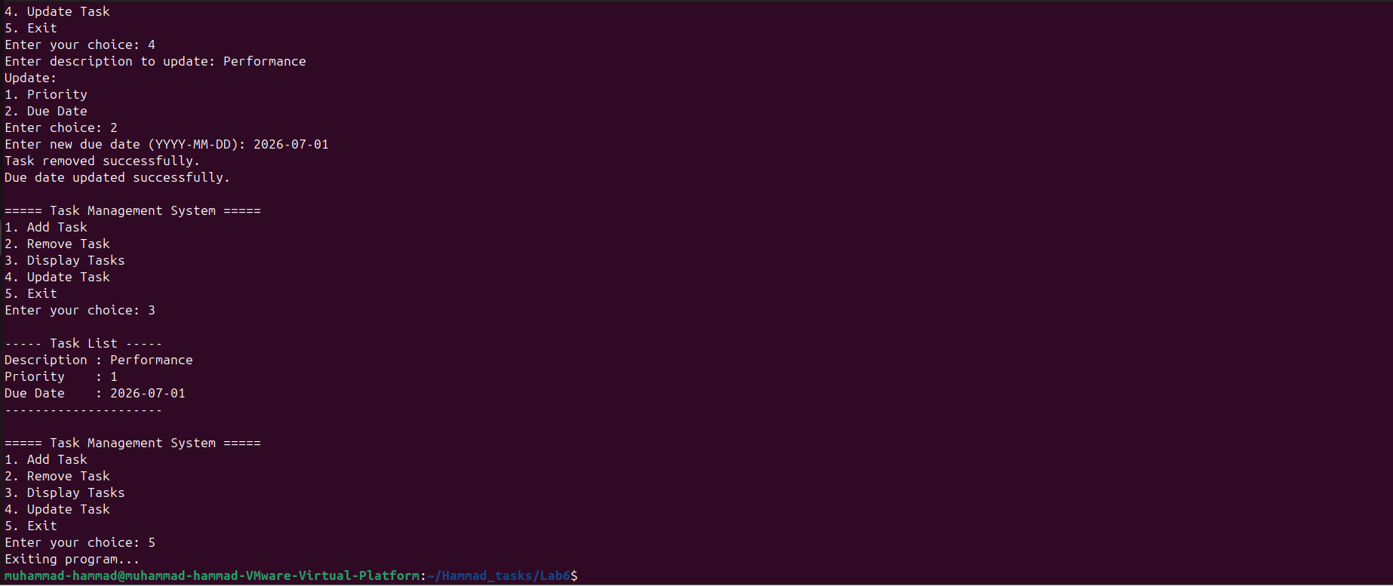
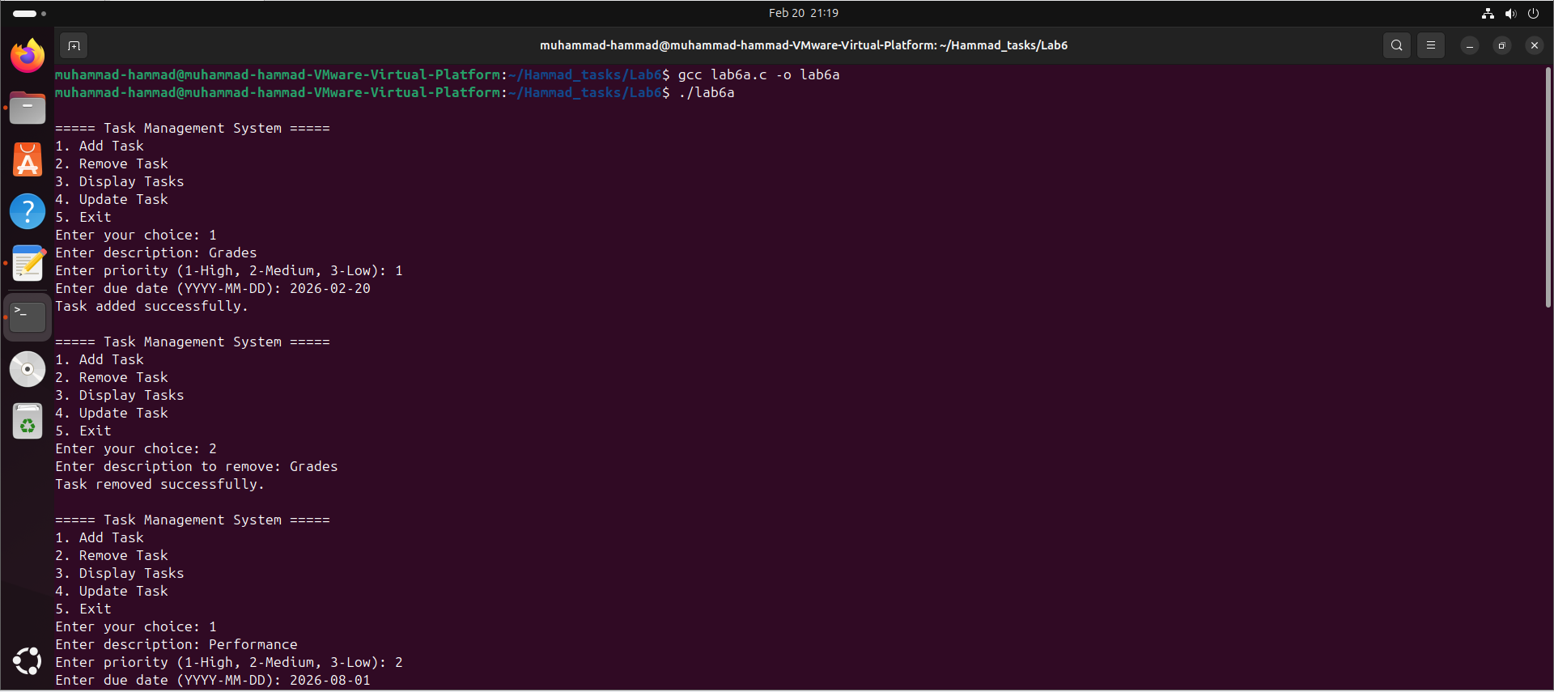
OUTPUT

FLOWCHART
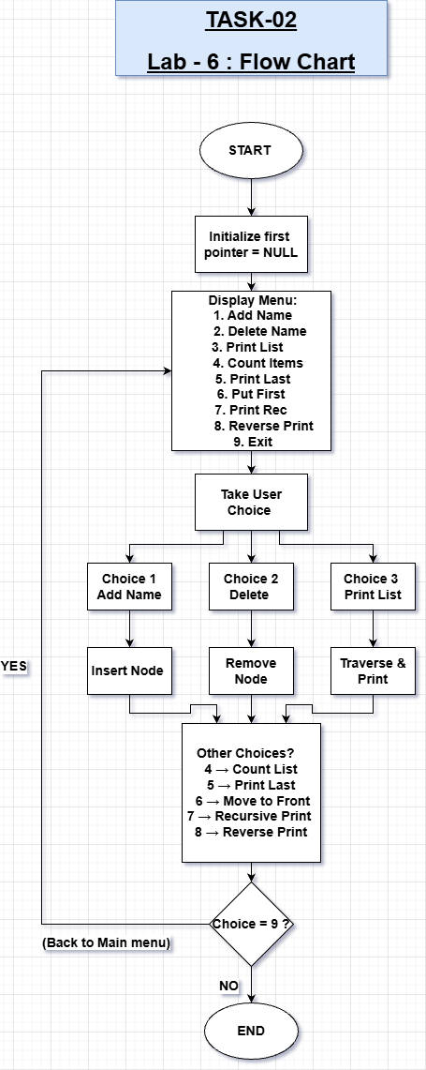

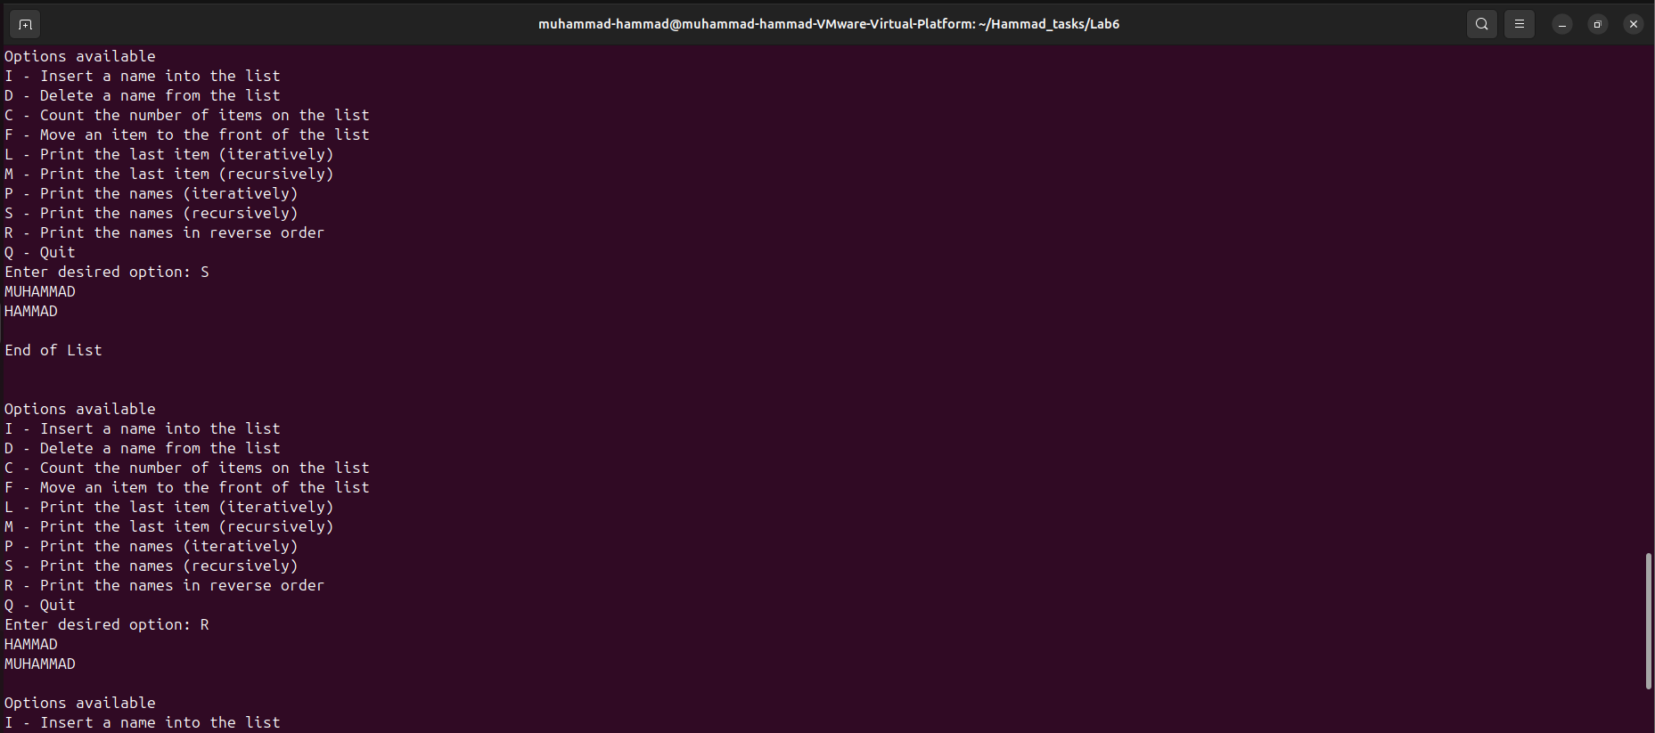
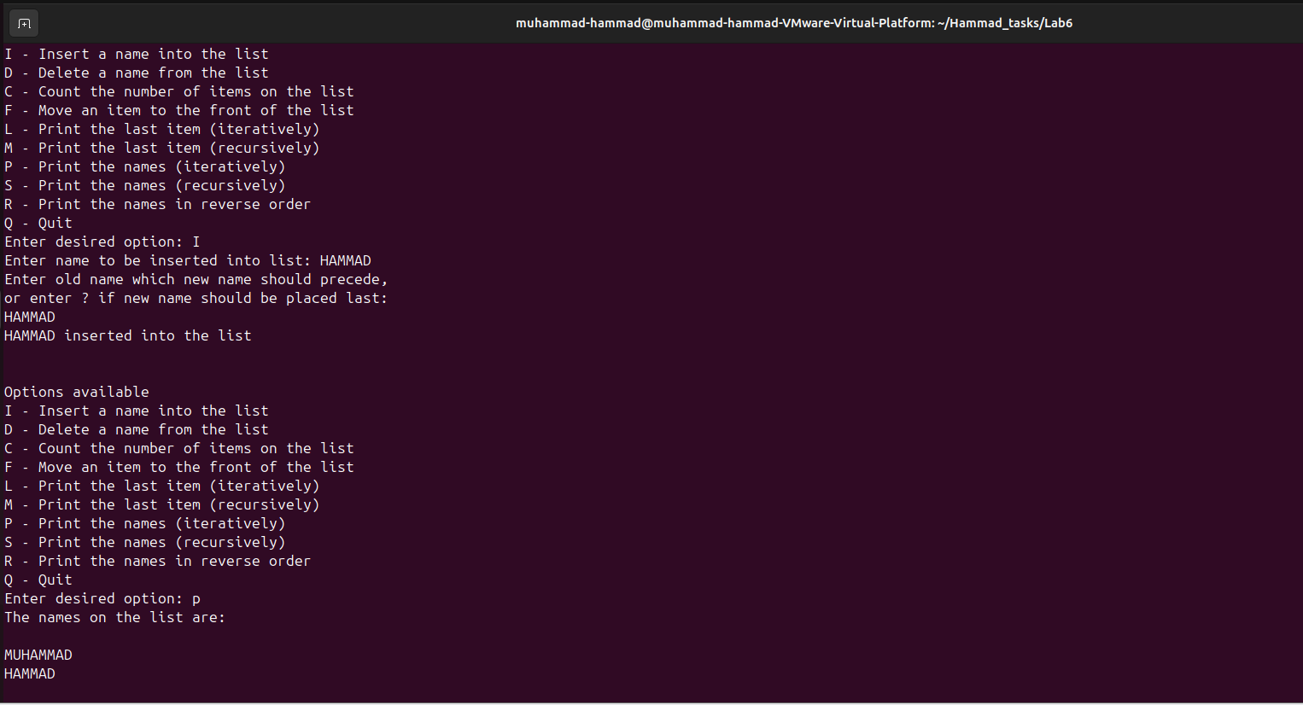
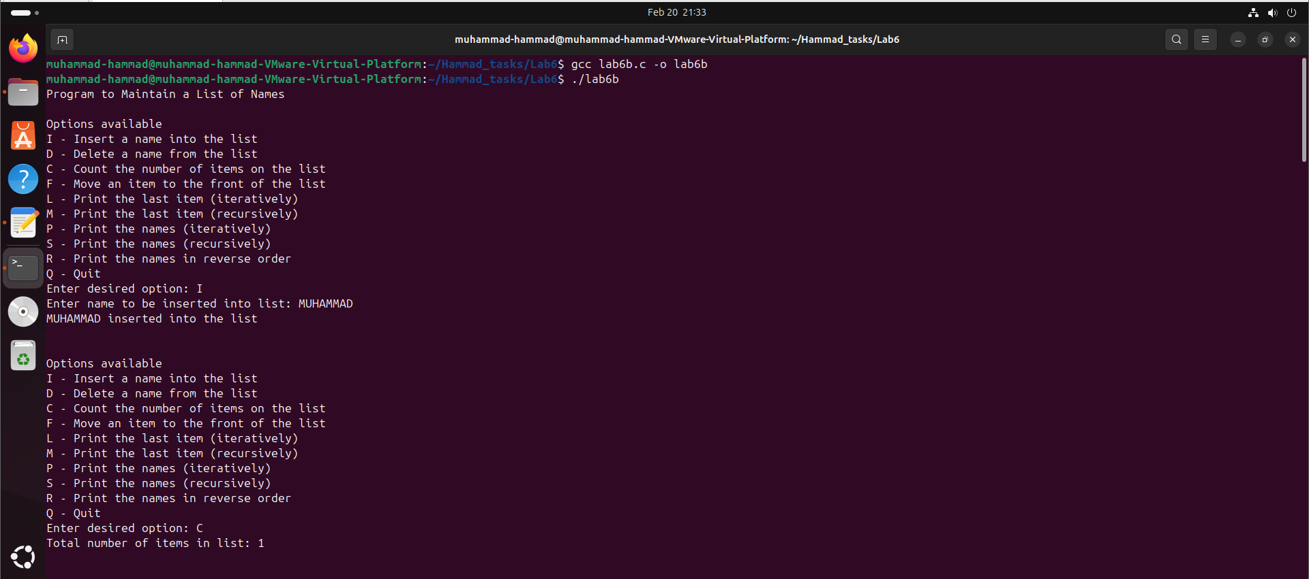
OUTPUT

FLOWCHART

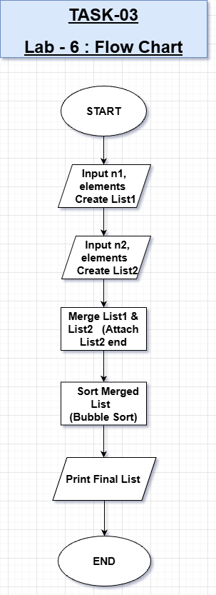

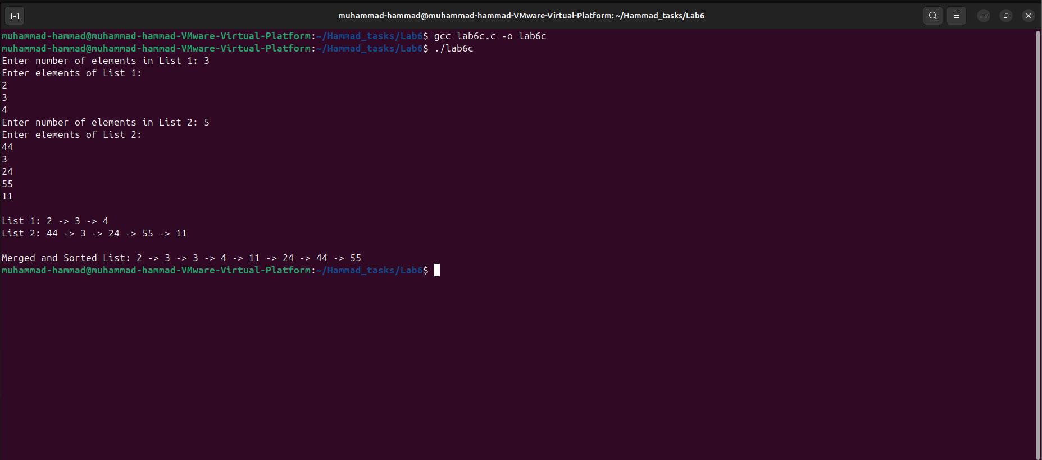
OUTPUT

Task #01 – Task Management System
- Implemented a singly linked list to manage tasks with description, priority, and due date.
- Add Task: Inserts based on earliest due date.
- Remove Task: Deletes a task by description.
- Display Tasks: Prints all tasks in order.
- Update Task: Modifies priority or due date (reorders list if due date changes).
Focus: Linked list traversal, dynamic memory, sorted insertion.

Task #02 – Name List with Pointers
- Menu-driven linked list program to manage names.
- Count Items: Iterative traversal.
- Print Last Item: Iterative and recursive versions.
- Move Item to Front: Reassigns pointers without creating/deleting nodes.
- Recursive Printing: Normal and reverse order.
Focus: Pointer manipulation, recursion, handling head pointer, edge cases.

Task #03 – Merge and Sort Linked Lists
- Create two unsorted integer linked lists.
- Merge Lists: Combine into one linked list.
- Sort Lists: Sort merged list in ascending order using pointers only.
Focus: Linked list merging, sorting without arrays, pointer-based operations.

CONCLUSION:

I learned to effectively use linked lists and pointers in C, including insertion, deletion, recursion, and sorting, while managing dynamic memory and implementing practical data structures efficiently.

